

CSE5011-Database Systems and Design

EMBEDDED LAB

**XML**

**KAUSHAL BAGHEL**

**21MAI0003**

**Consider the following XML data for solving the queries:**

https://docs.google.com/document/d/1y6x7q6OCdFqKfdcCjRkEPthEVL6b_gVQEAzxs4Q

qB7w/edit?usp=sharing

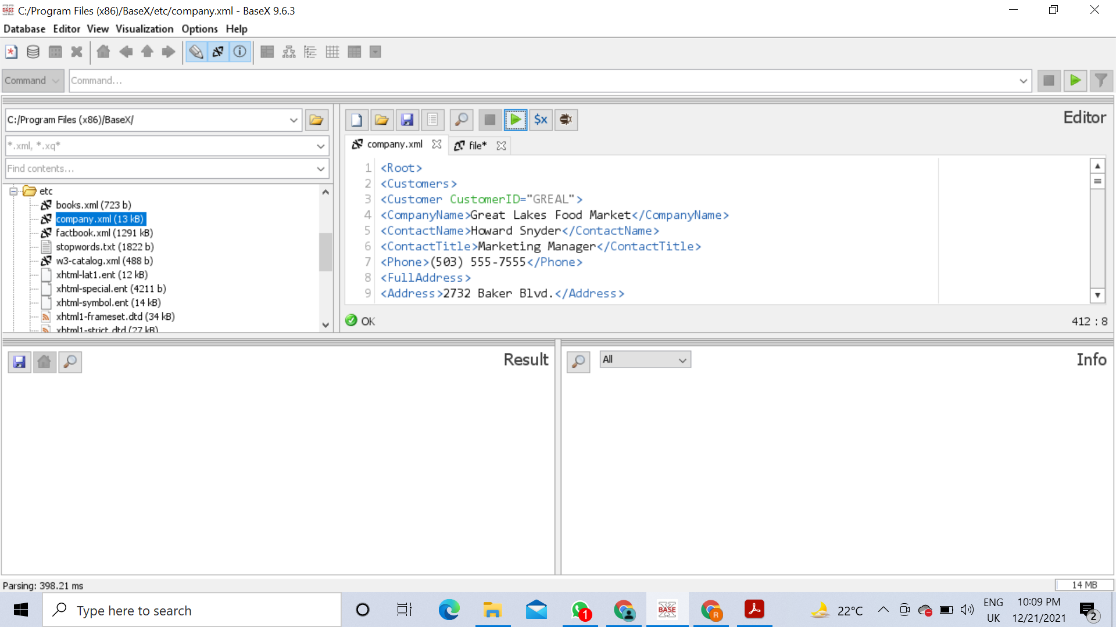

**Based on the XML data given write XML Query for the following:**

1. Read an XML file and its tags

**doc("company.xml")**

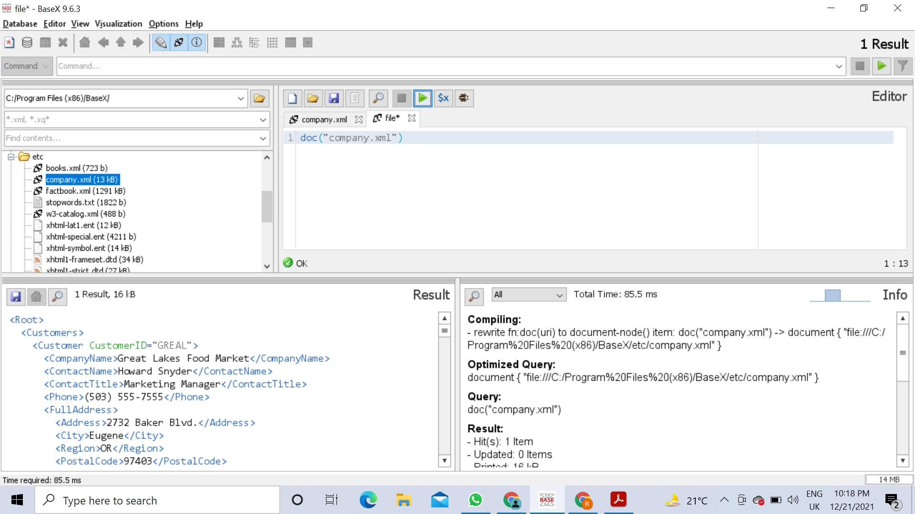

2. Apply Inline filter of an XML file and retrieve the details of 'Great Lakes Food Market’

**doc("company.xml")/Root/Customers/Customer[CompanyName="Great Lakes Food**

**Market"]**

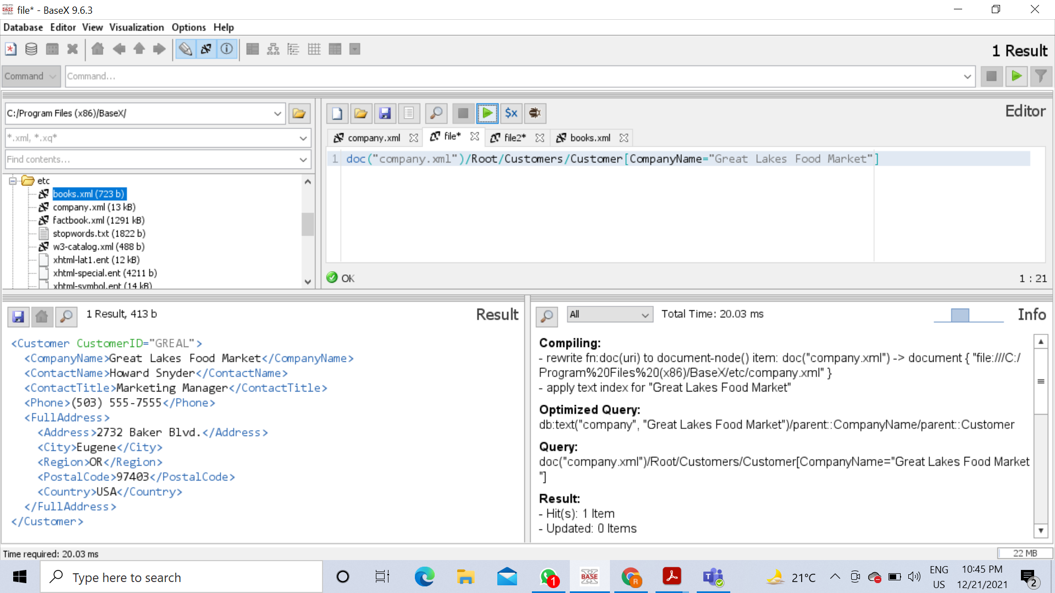

3. Apply Inline filter of an XML file and retrieve the details of ‘LETSS’

**doc("company.xml")/Root/Customers/Customer[@CustomerID = 'LETSS']**

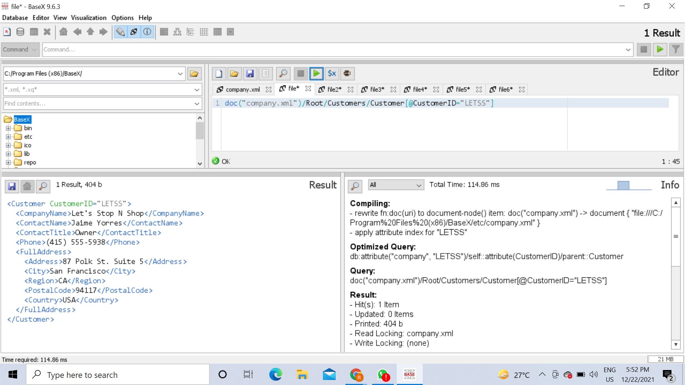

4. Find all the orders for the CA region

**doc("company.xml")/Root/Orders/Order[ShipInfo/ShipRegion="CA"]**

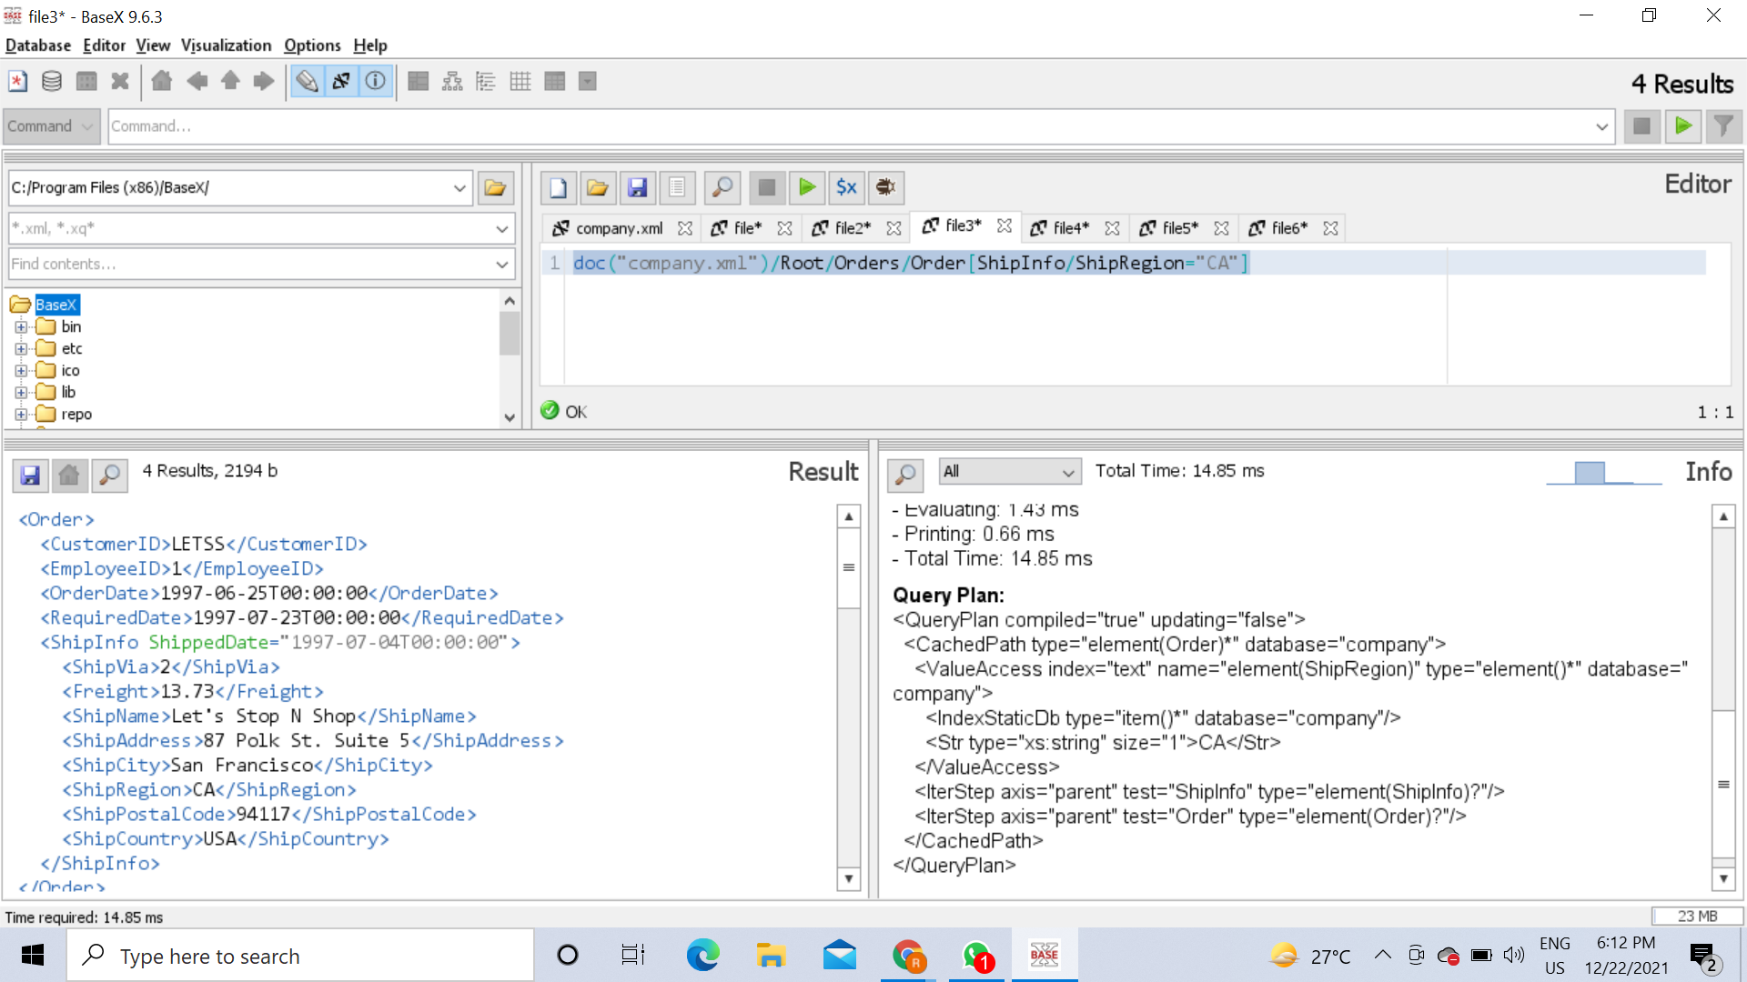

5. Order the output by the freight(Weight of the cargo)

**for $x in doc("company.xml")/Root/Orders/Order**

**order by xs:decimal($x/ShipInfo/Freight)**

**return $x/ShipInfo/Freight**

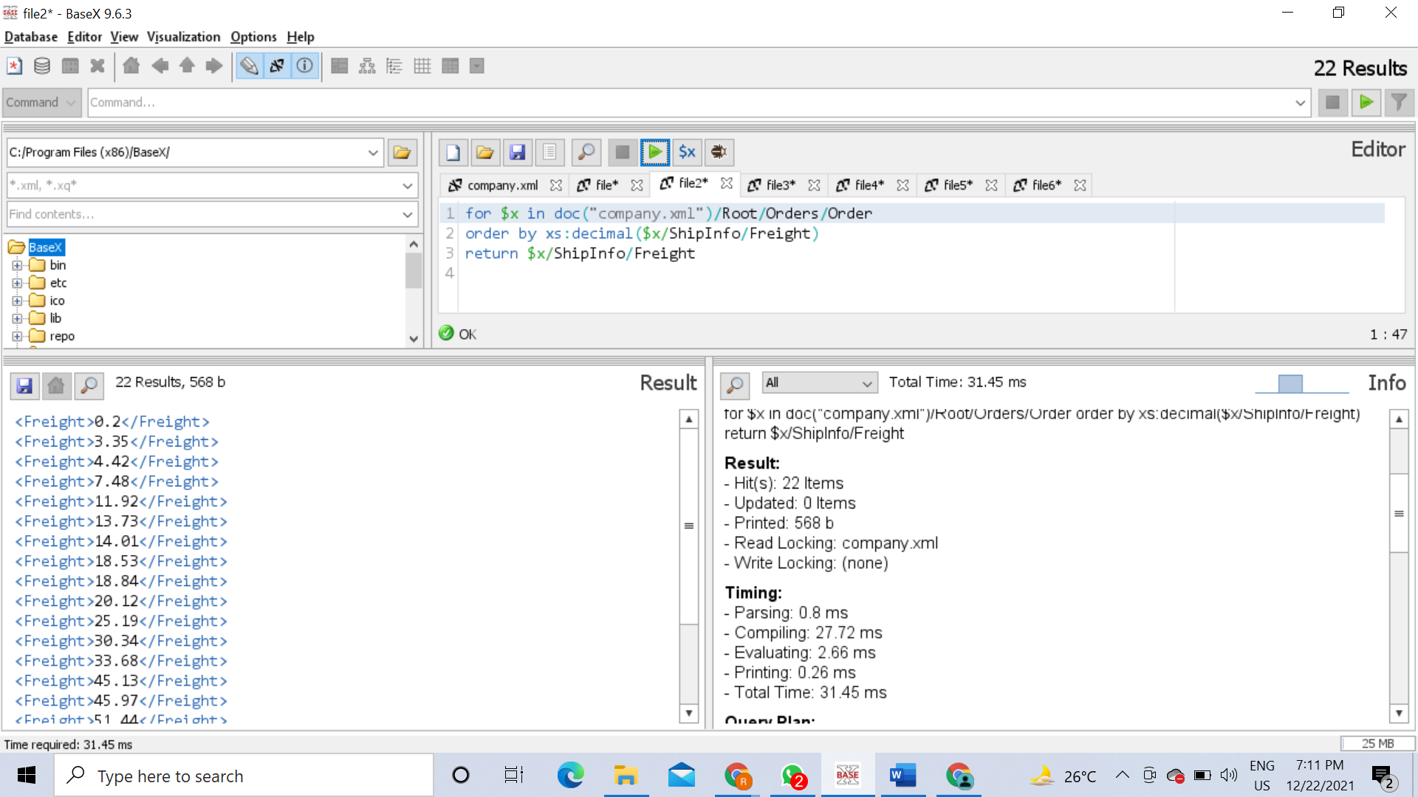

6. Insert xml data in html format for presentation by using a list

**<html>**

**<body>**

**<h1>COMAPNY</h1>**

**<ul>**

**{**

**for $x in doc("company.xml")/Root/Customers/Customer**

**order by $x/CompanyName**

**return <li>{data($x/CompanyName)}.CustomerID: {data($x/@CustomerID)} </li>**

**}**

**</ul>**

**</body>**

**</html>**

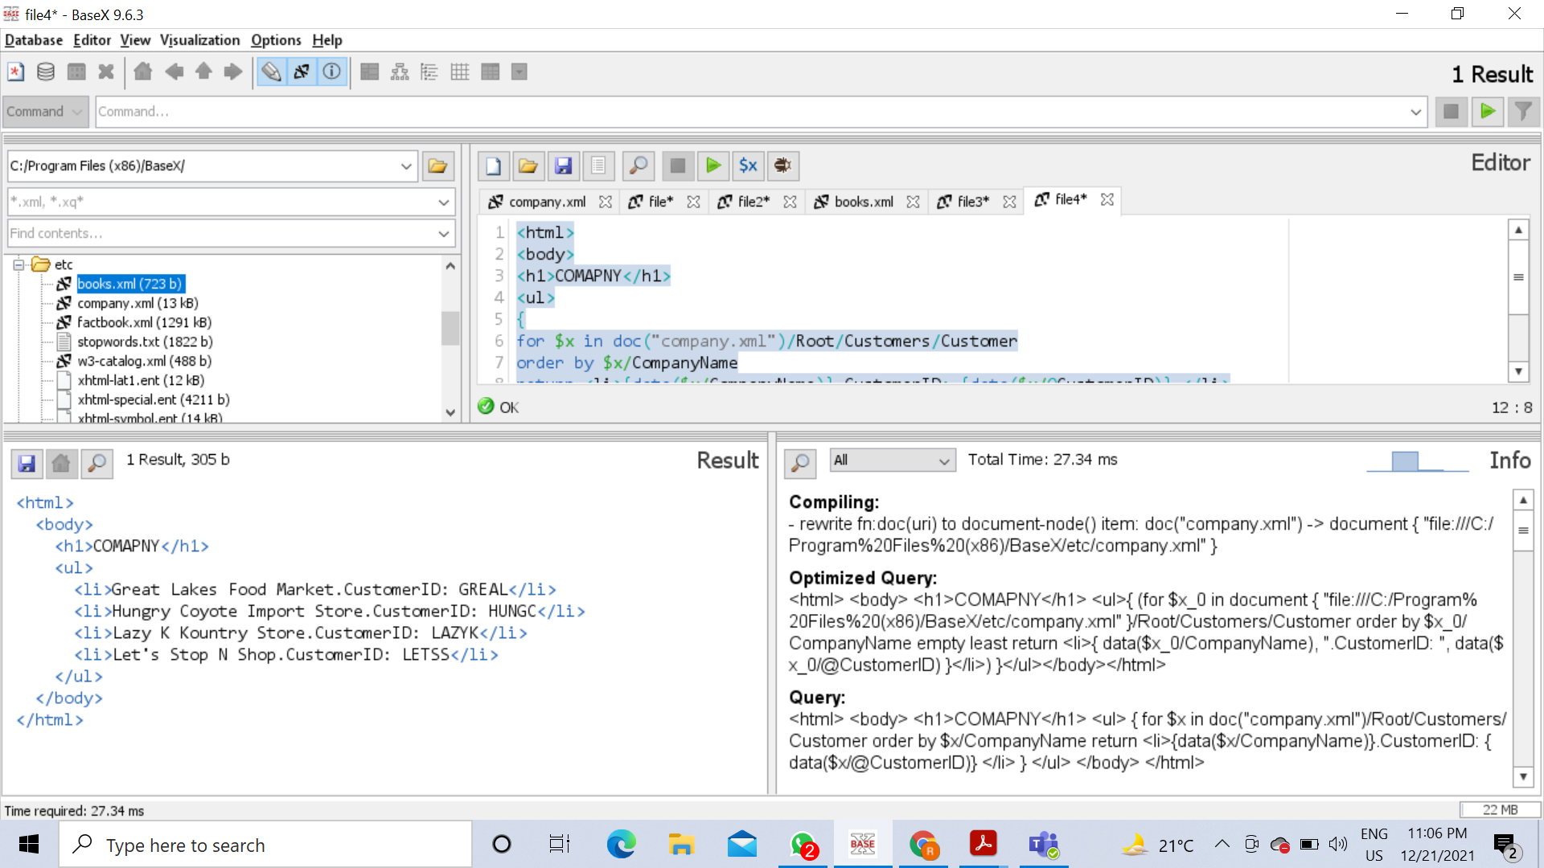

7. Insert only the data from the xml ignoring the xml tags. Hine: USe data() function

**<ul>**

**{**

**for $x in doc("company.xml")/Root/Customers/Customer**

**order by $x**

5**return <li>{data($x)} </li>**

**}**

**</ul>**

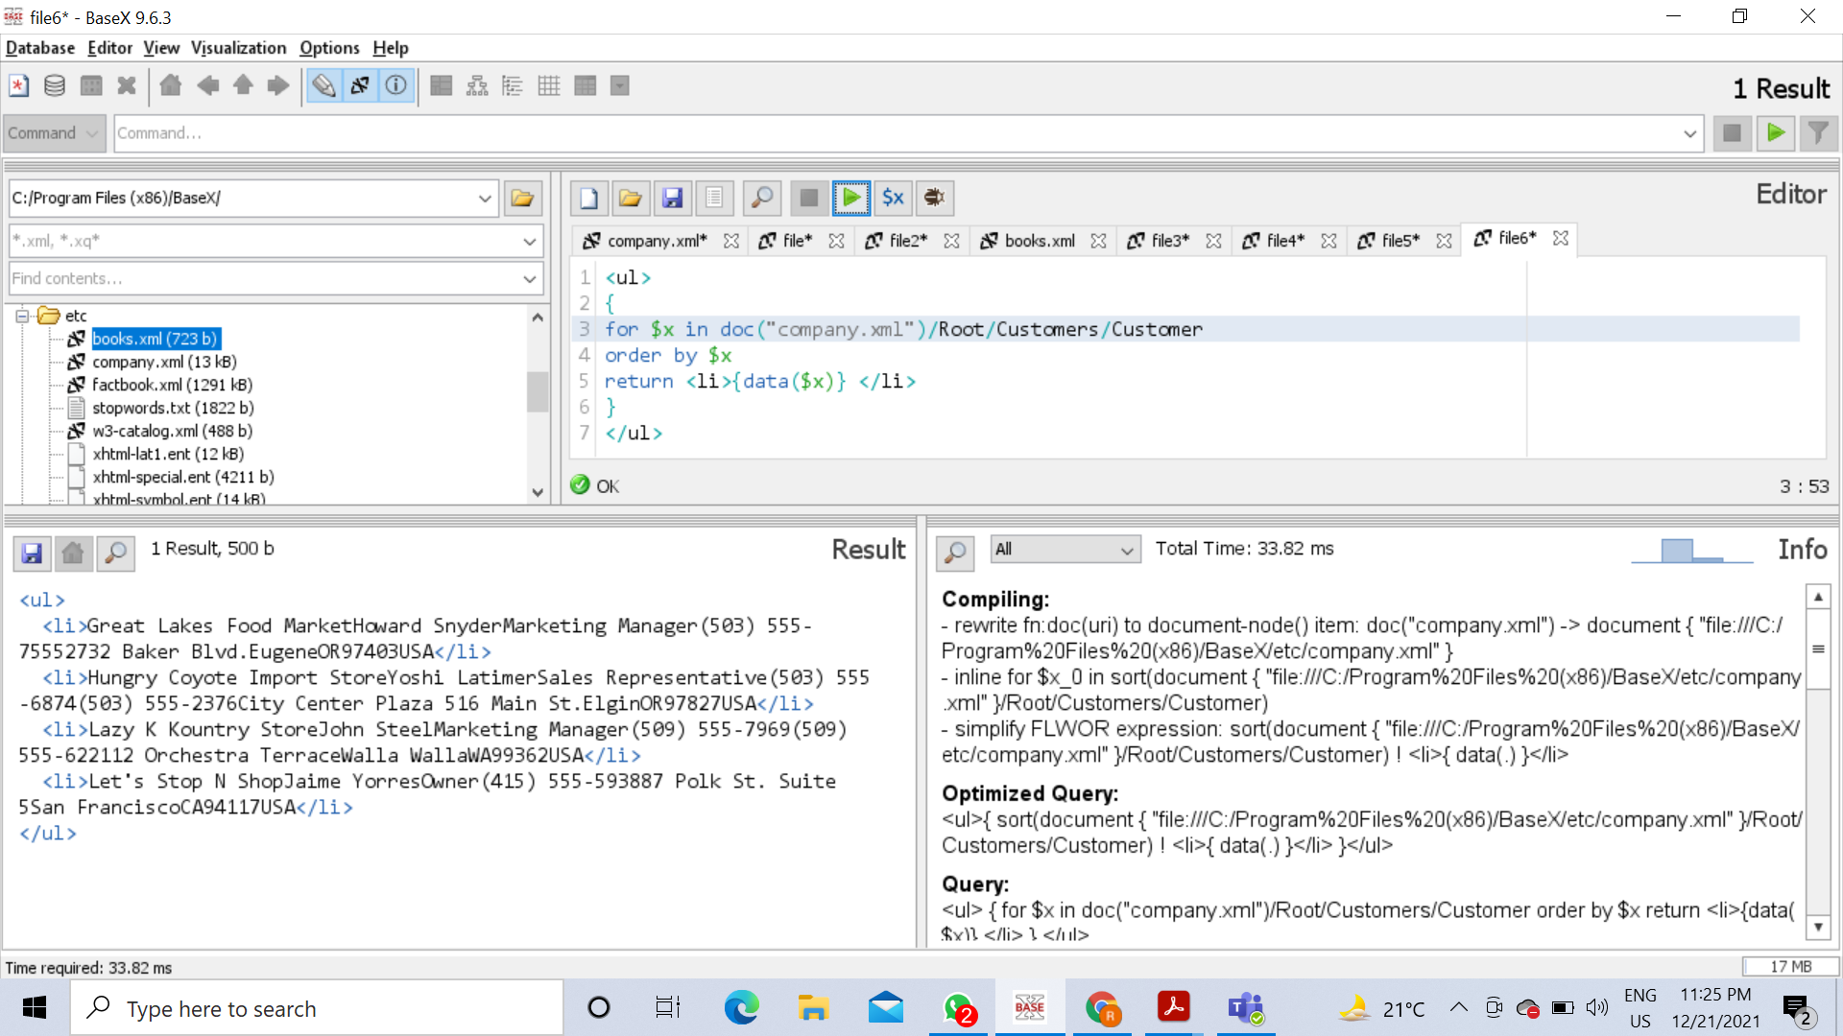

8. Use Conditional statement and retrieve the results for if the freight weight is above 10

(10000 Metric Tons)then it is tagged as a heavy load else a light load

**for $x in doc("company.xml")/Root/Orders/Order**

**return if ($x/ShipInfo/Freight>10)**

**then <heavyload>{data($x/ShipInfo/Freight)} </heavyload>**

**else <lightload>{data($x/ShipInfo/Freight)} </lightload>**

